GARDENCITY UNIVERSITY
NAME: PALLAVI B HANUMARADDER
ROLL NO: 24BECS188
SUBJECT: DESIGN THINKING [Lab 1]
TOPIC: Daily commuters face unpredictable public transport schedules.
OBSERVATION:
1. Frequency of Delays:
- Buses and trains often do not arrive at the scheduled time.
- Peak hours show higher unpredictability due to congestion and demand.
- Rural and semi-urban routes face more irregularity in arriving buses or trains as compared to metro-city services.
2. Impact on Commuters:
- Commuters frequently arrive late to workplaces, schools, or appointments. Most of the time students get punishments and awkwardness in their colleges because of late arrival to the classes or universities.
- Many commuters add buffer time of 10-30 minutes to their travel plans.
- Stress levels increase when schedules are unreliable, especially for students and employees.
3. Coping Mechanisms
- Commuters rely on mobile apps, announcements, or word-of-mouth for updates.
- Some switch to alternative modes (auto-rickshaw, taxi, walking, cycling) when delays occur.
- Regular commuters develop “personal strategies” like catching earlier buses or trains.
4. Economic & Social Effects
- Loss of productivity due to late arrivals.
- Increased expenditure when commuters are forced to use costlier alternatives.
- Reduced trust in public transport systems, leading to preference for private vehicles.
5. Infrastructure & Management Issues
- Lack of real-time communication about delays.
- Poor coordination between different transport modes (bus-train-metro).
- Inadequate frequency of vehicles during peak hours.
USER IDENTIFICATION/ STAKEHOLDERS
- Daily Commuters
  - Students, office workers, and others who rely on buses, trains, or metros.
  - They face stress, delays, and reduced productivity due to uncertainty.
- Public Transport Operators
  - Bus companies, metro authorities, railway services.
  - Responsible for scheduling, maintenance, and service reliability.
- Drivers & Staff
- Bus drivers, train conductors, ticketing staff.
- Their work schedules and efficiency directly affect service predictability.
SURVEY / INTERVIEWS
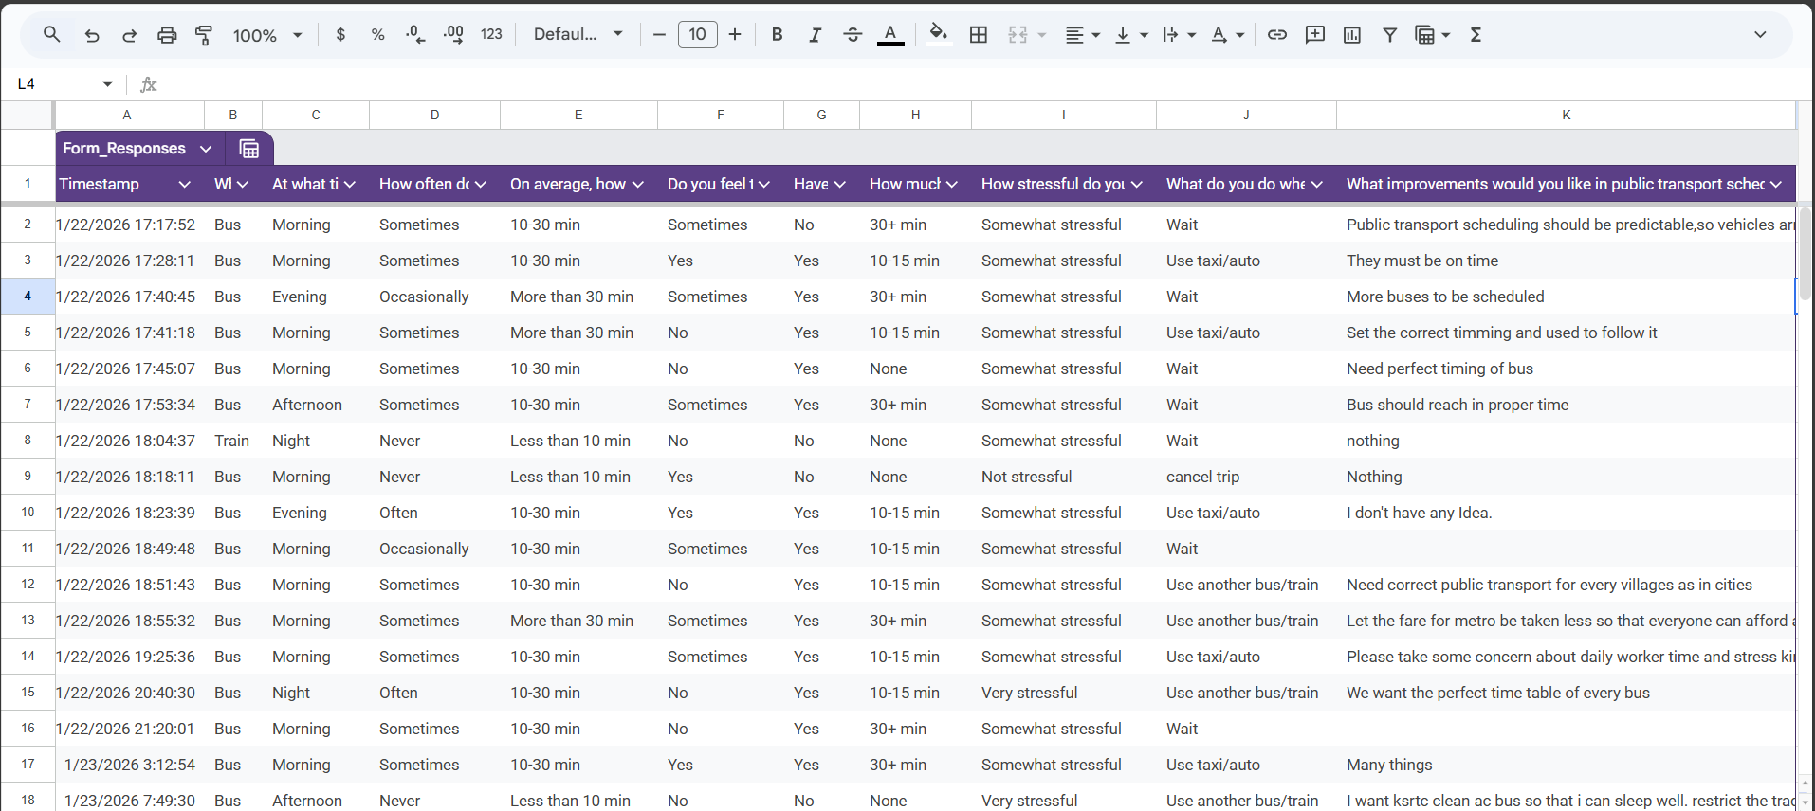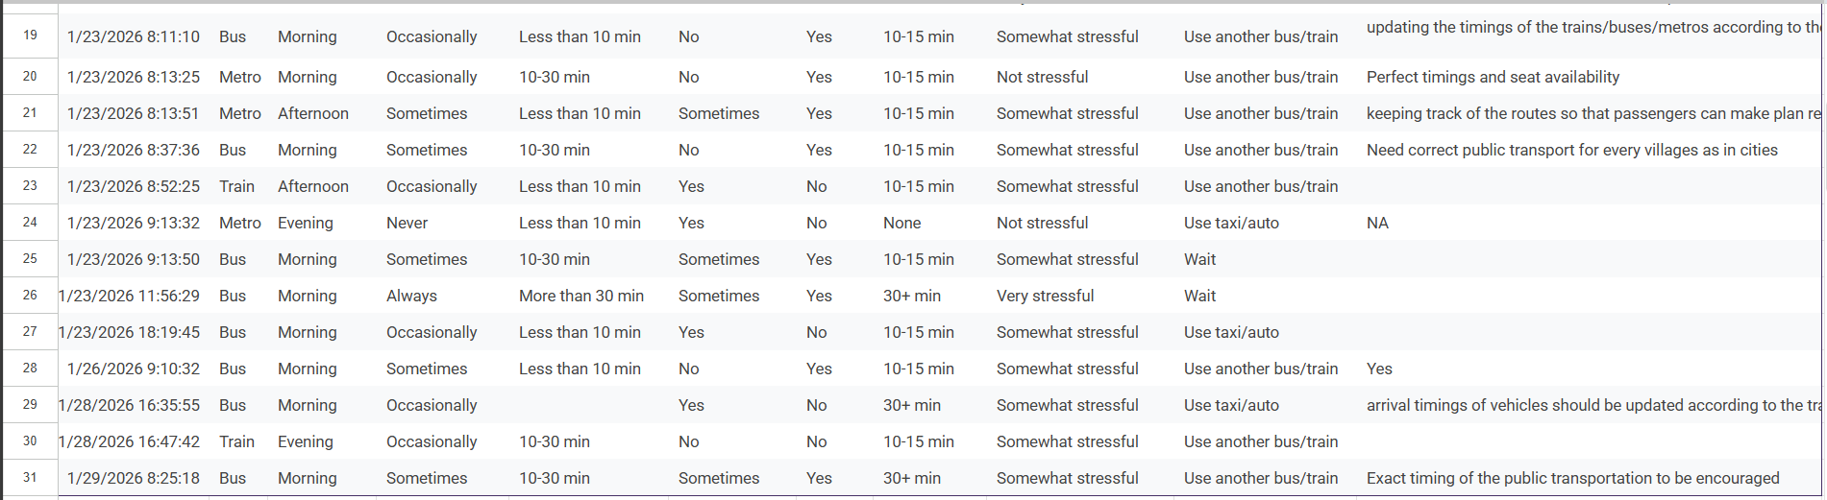
SURVEY SUMMARY
Travel Time
- Majority (10–30 min): Most commuters travel short to medium distances.
- Few (30 min): Very few have extremely short or long commutes.
Delay Frequency
- All respondents marked “Sometimes”: This shows a consistent issue with unpredictable schedules.
Stress Levels
- Mostly “Somewhat stressful”, with some “Very stressful.”
- No one reported “Not stressful,” indicating universal emotional strain.
Commuter Actions During Delays
- Most choose to “Wait.”
- Others use taxis/autos, cancel trips, or switch vehicles.
- This shows limited alternatives and high dependency on public transport.
Suggested Improvements
- Frequent themes: “Perfect timing,” “More buses,” “Set correct schedule,” “Be on time.”
- Some mention metro fare reduction and concern for daily worker stress.

PAIN-POINT ANALYSIS OF PUBLIC TRANSPORT SURVEY
1. Unpredictable Schedules
- Issue: Every respondent reported delays occurring “Sometimes.”
- Impact: Commuters cannot plan reliably, leading to missed school, work, and appointments.
- Pain Point: Lack of trust in public transport timing.
2. Stress and Emotional Strain
- Issue: Majority feel commuting is “Somewhat stressful,” with some reporting “Very stressful.”
- Impact: Daily anxiety, reduced productivity, and negative effects on well-being.
- Pain Point: Emotional burden of uncertainty and wasted time.
3. Limited Alternatives
- Issue: Most commuters simply “Wait” when transport is delayed.
- Impact: Few options for coping—taxis/autos are costly, canceling trips disrupts daily life.
- Pain Point: High dependency on unreliable public transport.
4. Overcrowding and Extended Travel Times
- Issue: Many commuters spend 10–30 minutes traveling, but delays extend this to 30+ minutes.
- Impact: Overcrowding during peak hours worsens stress and discomfort.
- Pain Point: Time inefficiency and physical strain.
5. Demand for Predictability
- Issue: Suggestions overwhelmingly call for “Perfect timing,” “More buses,” and “Set correct schedules.”
- Impact: Commuters want punctuality above all else, showing this is the top priority.
- Pain Point: Absence of a reliable timetable system.
Most critical pain points
- The root pain point is unpredictability, which cascades into stress, wasted time, and limited coping strategies.
- Secondary pain points include overcrowding and lack of affordable alternatives.
- Commuter voice is clear: they want punctual, frequent, and transparent scheduling
ROOT CAUSE IDENTIFICATION
This issue affects user stress levels, time management, and overall satisfaction. Let’s apply the 5-Why Analysis to uncover the root cause.
1.Why do people wait long for public transport?
Because buses or other transport modes are not arriving on time or frequently enough.
2. Why are buses not arriving on time or frequently?
Because the scheduling is inconsistent and not aligned with peak demand times.
3. Why is the scheduling inconsistent?
Because there is limited data-driven planning and poor coordination between transport authorities and commuter needs.
4. Why is there poor coordination and planning?
Because there is a lack of real-time monitoring and feedback systems to adjust schedules dynamically.
5. Why is there no real-time monitoring or feedback?
Because of limited investment in digital infrastructure and absence of commuter-centric policy frameworks.

Symptoms | Root Causes
- Long wait times reported by commuters  - High stress levels during commute  - Complaints about punctuality and frequency | - Poor scheduling and lack of demand alignment  - Absence of real-time data systems  - Limited investment in transport infrastructure and commuter feedback mechanisms

WICKED PROBLEM EXPLANATION: LONG WAITING TIMES IN PUBLIC TRANSPORT
1. Difficult to Define Clearly
- The issue varies by location, time of day, and individual perception.
- Some commuters report stress due to long waits; others tolerate delays if they have flexible schedules.
- “Waiting time” includes not just minutes but emotional impact, uncertainty, and missed opportunities.
2. Multiple Stakeholders with Conflicting Needs
Commuters want more buses; operators may resist due to cost.
- Planners may prioritize long-term infrastructure over short-term fixes.
- Conflicts arise between efficiency vs. equity, urban vs. rural needs, and profit vs. public service.
3. Cannot Be Solved by a Single Solution
- Adding buses may help some routes but worsen traffic elsewhere.
- Real-time tracking improves predictability but requires digital infrastructure.
- Behavioral change (e.g., staggered work hours) needs cultural and organizational shifts.
- Solutions must blend policy, technology, community feedback, and urban design.
Classification: Wicked Problem
This issue is not simple (like fixing a broken bus), nor merely complex (like optimizing a schedule). It’s wicked because:
- It’s deeply entangled with social, economic, and infrastructural systems.
- Every “solution” creates new challenges or shifts the problem elsewhere.
- It demands ongoing negotiation, adaptive strategies, and inclusive planning.
REFLECTION ON PUBLIC TRANSPORT DELAYS
Incorrect Assumptions
Initial assumption (technical/operational):
  - Delays were thought to be caused mainly by traffic congestion.
  - Lack of sufficient vehicles was seen as the core issue.
  - The problem appeared logistical in nature.
User perspectives (social/emotional dimensions):
  - Stress: Commuters experience anxiety and frustration due to unpredictability.
  - Punishments at schools: Students arriving late face disciplinary actions, affecting morale.
  - Awkwardness in colleges: Late arrivals create embarrassment and social discomfort.
  - Financial burden: Switching to costlier alternatives (like autos or taxis) strains household budgets.
Deeper realization:
- Delays are not just about logistics but about human-centered impacts.
- They affect dignity (being judged for lateness), trust (reliability of services), and daily routines (school, work, family).
- The issue intertwines operational inefficiency with social consequences.
Changed Understanding from User Perspectives
At first, I thought delays were only because of traffic jams or not enough buses/vehicles.
- But when I listened to people, I saw delays cause bigger problems in daily life:
  - Stress and worry.
  - Punishments at school for being late.
  - Embarrassment in college classes.
  - Extra money spent when people take autos or taxis.
- So, delays are not just about buses being late. They also hurt people’s feelings, dignity, trust, and routines.

